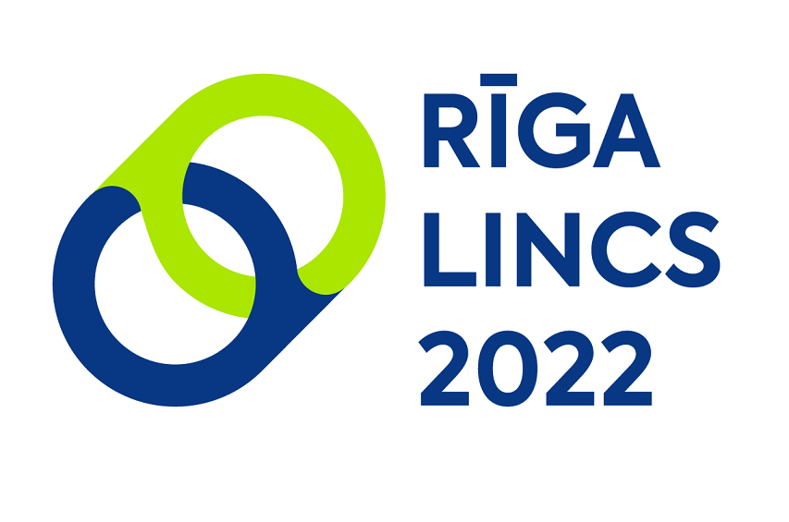

**5th International Symposium**

**Language for International Communication**

**Linking Interdisciplinary Perspectives:**

**Language for Specific Purposes**

**in the Era of Multilingualism and Technologies**

**April 28-29, 2022**

**online symposium from the University of Latvia**

**Riga, Latvia**

**Call for Papers**

The University of Latvia hosts the 5th International Symposium on Language for International Communication organized by the Department of English Studies and the Centre for Applied Linguistics in cooperation with the Department of Romance Studies at the Faculty of Humanities. The University of Latvia is pleased to announce that the symposium will be held online from Riga on **April 28-29, 2022.**

The symposium invites the debate on new perspectives and developments in research on Language for Specific Purposes (LSP) and specialised discourse and welcomes contributions from such fields as terminology, genre studies, discourse studies, pragmatics, sociolinguistics, to mention some. The scholars are encouraged to share their insights into the aims and methods of current research on LSP and specialised discourse, by reviewing LSP status and emergent issues. The symposium aims at gaining a holistic overview of state-of-the-art research in LSP area.

The symposium aims at bringing together scholars, practitioners and emerging researchers in LSP as well as language technology product developers and providers. The participants are invited to share their research and practical know-how of teaching LSP to students of different training programmes, connecting the language classroom with workplace relevance. The forum for young researchers will be held in conjunction with the symposium and as such will provide students and junior researchers with the opportunity to present their research and receive feedback from experienced scholars.

**Important dates**

Submission of abstracts (online): **January 17, 2022**

Notification of acceptance of the abstracts: **February 14, 2022**

Early bird registration opens: **February 21, 2022**

Early bird registration closes & regular registration opens: **March 14, 2022**

The symposium fee is payable by bank transfer by **March 28, 2022**

Online registration closes on **March 28, 2022**

Online symposium: **April 28-29, 2022**

Submission of the manuscript electronically for review: **September 10, 2022**

**The focus of the symposium is on** **but not limited to**

**Multilingualism** in LSP

- Specialised discourse (business, law, medicine, engineering, cultural and literary studies, etc.);

- Theory and methodology of LSP research;

- Terminology interface of theory and practice in LSP;

- Corpus studies in LSP;

- Translation and interpretation in LSP.

**Technologies** in LSP

- Innovation, multimodality and digital technologies in LSP studies;

- OER (Open Educational Resources) in LSP teaching and learning;

- Game and game-based approaches in LSP teaching and learning;

- Influence of technologies on LSP integration with teaching and learning of other subjects.

**Keynote speakers**

**DAY 1**

**Vita Kalnbērziņa** (University of Latvia, Latvia) ***Onsite versus online studies: student perspective***

**Ingūna Skadiņa** (University of Latvia, Latvia) ***Latvian language resources and tools for research, education and technology development***

**Crispin Thurlow** (University of Bern, Switzerland) ***No strings attached? Multilingual performance and fleeting conviviality in host-tourist encounters***

**DAY 2**

**Liliana Szczuka-Dorna**, ex-president of CercleS (Poznan University of Technology, Poland) ***ESP Quo Vadis?***

**Ángel Felíces Lago** (University of Granada, Spain) ***Why the cultural briefing is also necessary among Spanish-speaking countries? Non-verbal cross-cultural differences under scrutiny***

**Presentation mode**

**Presenters (Oral Presentation) – Live ZOOM Presentation**

Each Presenter will get 15 Minutes to do their Presentation (PPT is Recommended).

Each Presenter will have 5 Minutes for Q&A Session

**Posters (Poster Presentation)**

Each Poster will be displayed at the Conference Poster Wall (Poster Template)

**Panel discussion**

Panellists will be selected from among the contributors by the Organizing Committee.

**The working languages**

The working languages of the symposium are **English, French**, and **Spanish.**

**Conference Proceedings**

Submission of the manuscript electronically for review: **September 10, 2022.**

All submitted conference papers will be blind peer reviewed by competent reviewers, and the papers with positive reviews will be published in the ***Language for International Communication: Linking Interdisciplinary Perspectives: Language for Specific Purposes in the Era of Multilingualism and Technologies*** proceedings (indexed by EBSCO databases: Communication Source and Central & Eastern Europe Academic Source).

Selected papers will be published in the ***Baltic Journal of English Language, Literature and Culture*** – a multidisciplinary international scientific journal in general linguistics, applied linguistics, literature and culture (indexed by Web of Science, EBSCO databases: Central & Eastern Europe Academic Source, EBSCO Discovery Service, the EBSCO Humanities Source,

and Google Scholar).

**Symposium fee**

Participation and publication fee (by bank transfer)

**Early Bird Registration Rates**

(Applicable to those who register by March 14th)

- Presenting Author: **EUR 70**;

- Presenting Co-authors: **EUR 35**;

- Presenting Author (PhD Student, co-authored by thesis supervisor): **EUR 35**;

- Attendee: **EUR 10**

**Regular Registration Rates**

(Applicable to those who register after the early-bird deadline)

- Presenting Author: **EUR 90**;

- Presenting Co-authors: **EUR 45**;

- Presenting Author (PhD Student, co-authored by thesis supervisor): **EUR 45**;

- Attendee: **EUR 10**

The payment includes confirmation of participation at the conference, the scientific publication, and the symposium package.

The symposium fee is payable by bank transfer by **March 28, 2022**. Details regarding the payment and the deadline will be communicated together with the notification of acceptance.

If the editorial board rejects the article in the review process as either thematically or qualitatively inappropriate, the publication fee is not refunded. The same applies in the case of authors, withdrawing their manuscript.

**Scientific committee and editorial board:**

**Editor-in-Chief:** Dr. philol. Laimdota Ločmele (University of Latvia, Latvia)

**Managing Editors:** Dr. philol. Jeļena Vladimirska (University of Latvia, Latvia)

Dr. philol. Alla Placinska (University of Latvia, Latvia)

**English**

Dr. habil. philol. Andrejs Veisbergs (University of Latvia, Latvia)

Dr. philol. Clara Sarmento (University of Porto, Portugal)

Dr. philol. Lucyna Harmon (University of Rzeszów, Poland)

Dr. philol. Satu Tuomainen (University of Eastern Finland, Finland)

Dr. philol. Libor Stepanek (Masaryk University, Czechia)

Dr.philol. Eva Braidwood (University of Oulu, Finland)

Dr. philol. Marina Bondi (University of Modena and Reggio Emilia, Italy)

Dr. philol. Maria Pilar Alberola Colomar (University of Florida in Valencia, Spain)

Dr. philol. Vita Kalnbērziņa (University of Latvia, Latvia)

Dr. philol. Laura Karpinska (University of Latvia, Latvia)

Dr. philol. Jana Kuzmina (University of Latvia, Latvia)

Dr. philol. Gunta Roziņa (University of Latvia, Latvia)

Dr. philol. Zigrīda Vinčela (University of Latvia, Latvia)

Dr. philol. Kevin Haines (University of Bristol, UK)

Dr.philol. Maria Kuteeva (Stockholm University, Sweden)

Dr. paed. Monta Farneste (University of Latvia, Latvia)

Dr. paed. Dace Liepiņa (University of Latvia, Latvia)

Dr. paed. Ineta Lūka (Turiba University, Latvia)

**French**

Dr. philol. Jeļena Vladimirska (University of Latvia, Latvia)

Dr. philol. Hélène Vassiliadou (University of Strasbourg, France)

Dr. philol. Sophie Vassilaki (University of Languages and Civilizations, France)

Dr. philol. Serge Tchougounnikov (University of Burgundy, France)

Dr. philol. Elodie Vargas (University of Grenoble, France)

**Spanish**

Dr. philol. Alla Placinska (University of Latvia, Latvia)

Dr. philol. Carlos Alvar (University of Alcalá de Henares, Spain)

Dr.philol. Ángel Felíces Lago (University of Granada, Spain)

Dr. philol. Maria Victoria López Pérez (Public University of Navarra, Spain)

Dr. philol. Carmen Sánchez Manzanares (University of Murcia, Spain)

Dr. philol. José Antonio Alonso Navarro (Norte University, Paraguay)

Dr. philol. Andjelka Pejovic (University of Belgrad, Serbia)

**Organizing Committee:**

Head of the Organizing Committee: Dr. philol. Laimdota Ločmele (University of Latvia, Latvia)

Dr. paed. Dace Liepiņa (University of Latvia, Latvia)

Dr. philol. Laura Karpinska (University of Latvia, Latvia)

Dr. philol. Alla Placinska (University of Latvia, Latvia)

Dr. philol. Jelena Vladimirska (University of Latvia, Latvia)

Dr. paed. Inta Līsmane (University of Latvia, Latvia)

MA philol. Margarita Spirida (University of Latvia, Latvia)

MA philol. Līga Beļicka (University of Latvia, Latvia)

MA philol. Jekaterina Čerņevska (University of Latvia, Latvia)

Please submit your abstracts in the symposium website: <https://conferences.lu.lv/e/lincs>.

For more detailed information, please see the attachment or contact us on [lincs@lu.lv](mailto:lincs@lu.lv) or [liga.belicka@lu.lv](mailto:liga.belicka@lu.lv) for queries in English; [alla.placinska@lu.lv](mailto:alla.placinska@lu.lv) – in Spanish; [jelena.vladimirska@lu.lv](mailto:jelena.vladimirska@lu.lv) – in French.